South Western Ophthalmological Society Meeting  8 June 2018 |  |  | Venue:  Somerset County Cricket Club  Taunton  Somerset  TA1 1JT
 | Provisional Programme  Matthew Burton:  09:00 Registration and Coffee  09:45 "Fungal Keratitis: Epidemiology, Diagnosis and Treatment"  Prof Matthew Burton, International Centre for Eye Health, London School of Hygiene & Tropical Medicine/Moorfields Eye Hospital, London  10:30 “Acanthamoeba Keratitis”  Ms Valerie Saw, Imperial College Healthcare NHS Trust  11:00 Tea/Coffee  11:30 "Peripheral Ulcerative Keratitis"  Prof Matthew Burton, International Centre for Eye Health, London School of Hygiene & Tropical Medicine/Moorfields Eye Hospital, London  12:00 “Cicatrising Conjunctivitis - Diagnosis and Management”  Ms Valerie Saw, Imperial College Healthcare NHS Trust  12:40 “Clinical Research for Ophthalmology” - Goals for Research in the Region  Ms Brinda Shah, SW Peninsula Speciality Lead for Ophthalmology for the Clinical Research Network, NIHR  13:00 Lunch  13:50 “The Dichoptic Approach to Treating Amblyopia”  Mrs Kate Barnes, Musgrove Park Hospital  14:30 “The Good, The Bad and The Lumpy”  Miss Siobhan Rattigan, Musgrove Park Hospital  15:10 “The Excavated Disc” - Not all are glaucomatous  Miss Rani Sebastian, Glaucoma Subspecialty Lead, Bristol Eye Hospital  15:40 Tea  16:00 “Ocular Surface Disease in Atopy and Rosacea”  Ms Valerie Saw, Imperial College Healthcare NHS Trust  16:30 “Dermatitis, Eczema and Periocular Oedema”  Dr Jane Sansom, Consultant Dermatologist, University Hospitals Bristol |  | 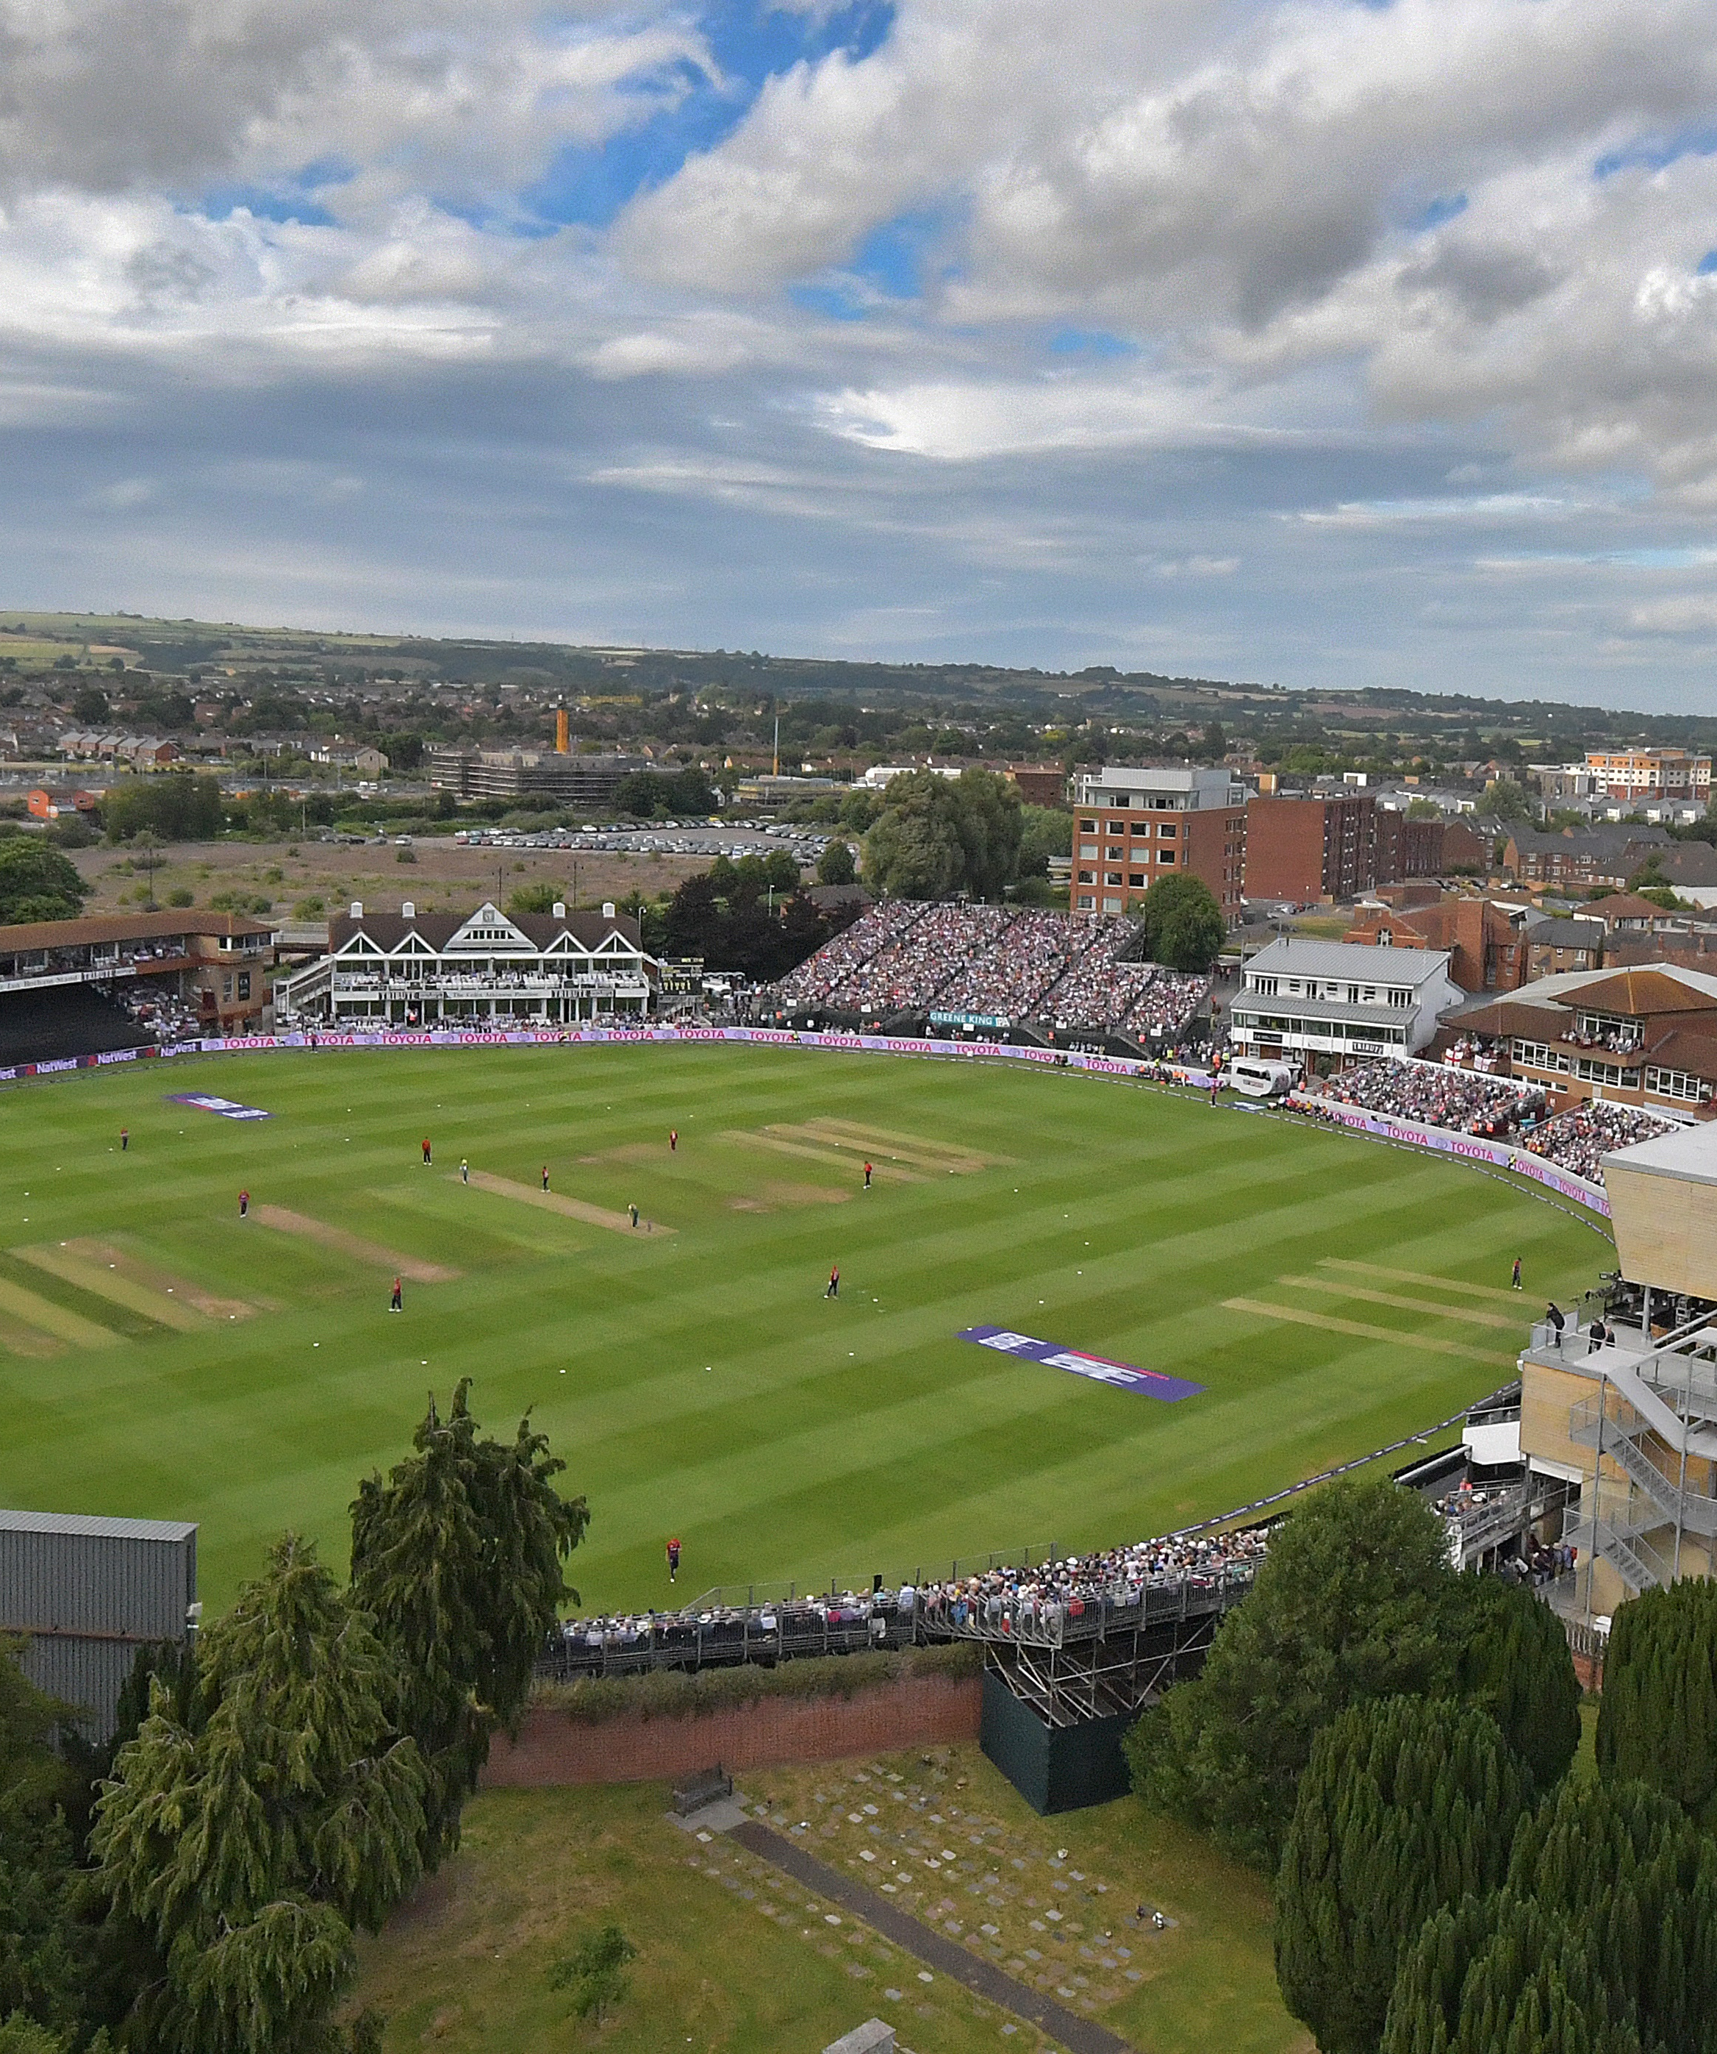  Registration:  Please confirm attendance to Lorraine Cridlin, Secretary to  Mrs H M Herbert,  Consultant Ophthalmologist,  by 8 May 2018  (Please advise of any dietary requirements.)  Email: lorraine.cridlin@tst.nhs.uk  Phone: 01823 344122

