South West Ophthalmological Society (SWOS) meeting,

Friday 17th June 2016, Cheltenham Racecourse

Academic agenda, and commercial exhibit in ‘Sovereign’ and ‘Crest rooms’ respectively, coffees and lunch in ‘Panoramic Restaurant’

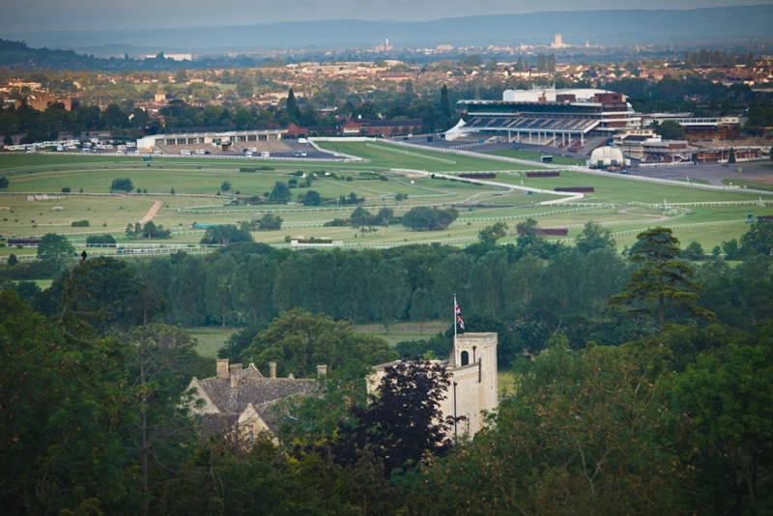

SWOS Programme, Friday 17th June:

9.00-9.30am: Arrival, registration and coffee

9.30-11.00am: Opportunities for trainees, and interested consultants, to take part in dry lab surgical training using realistic ‘simulated ocular surgery’ plastic eyes. Eyes suitable for training in squint, retinal detachment scleral buckling, and glaucoma surgery eg trabeculectomy will be provided, as well as tabletop surgical microscopes, instruments, sutures etc. Interested surgeons should also bring their own surgical loupes, as this will ease demand for surgical microscopes. Local consultants will be available to give advice, but all interested trainees and consultants are encouraged to attend. This is intended to be a stimulating but completely informal session for all interested ophthalmologists, of any level of experience!

11.00-11.30am: Coffee

11.30-12.10am: John Ferris (Gloucestershire Hospitals) ‘Simulated ocular surgery’

12.10-12.50pm: Prof Paul Artes (Plymouth University, Devon) ‘Visual Fields’

12.50-2.00pm: Lunch (Panoramic Restaurant)

2.00-2.45pm: Prof Geoff Rose (Moorfields Eye Hospital, London) ‘Tales of the unexpected’

2.45-3.30pm: Prof Peter Scanlon (Gloucestershire Hospitals) ‘Surveillance for diabetic macular oedema’

3.30-4.00pm: Coffee

4.00-4.30pm: Alastair Laidlaw (St Thomas’ Hospital, London) ‘Vitrectomy for diabetic macular oedema’

4.30-5.00pm: Robert Johnston (Gloucestershire Hospitals) ‘Measuring quality in ophthalmology’

6.00pm: Dinner at restaurant in Cheltenham

IMPORTANT NOTE: Please let me know in advance if:

a) You are planning to attend this SWOS meeting,

b) Whether you will be taking part in the morning surgical training session (so we have some idea of numbers), and

c) Whether you would like to come to the dinner in Cheltenham after the conference,

via my secretary,

Charlotte Baugh, at charlotte.baugh@glos.nhs.uk
Direct phone: 01242272527

Map for Cheltenham Racecourse below. The Racecourse is a short taxi ride from ‘Cheltenham Spa’ railway station. On arrival, park near the Centaur building, and walk through the ‘Hall of Fame’ foyer to the meeting rooms, namely ‘Sovereign’ and ‘Crest’.

